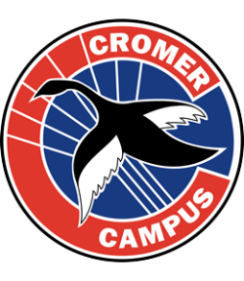
All raised funds will be used to purchase
Recycling Bin Enclosures throughout the school.
DATE: Tuesday, 12th November
TIME: 4pm – Golf, 6pm Dinner
WHERE: Cromer Golf Club

Purchase Tickets here:
https://nbsccromercampuspc.teamapp.com/events/8847808
NBSC Cromer Campus P&C
Golf & Dinner
Fundraising Event
$500 LUCKY DOOR PRIZE
for one of our Lucky Diners!
Be sure to check out our Online Auction prizes: weekends away, vouchers, experiences, services and more!
REGISTER NOW and start BIDDING:
http://CromerCampus.famb.bid
Our Golf & Dinner event would never be a success without the generous support of our Sponsors. THANK YOU!

